

**WORLD PEST CONTROL & LOGISTICS**

**Marshal House, 33/1, N.S Road, Room No-752,7th floor,**

**Kolkata- 700 001**

**Ph: 9748002232/7003498554, E mail: worldpestcontrol.operation@gmail.com**

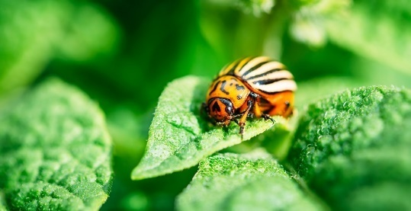

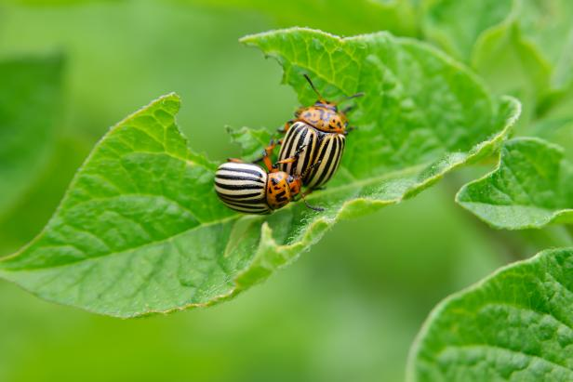

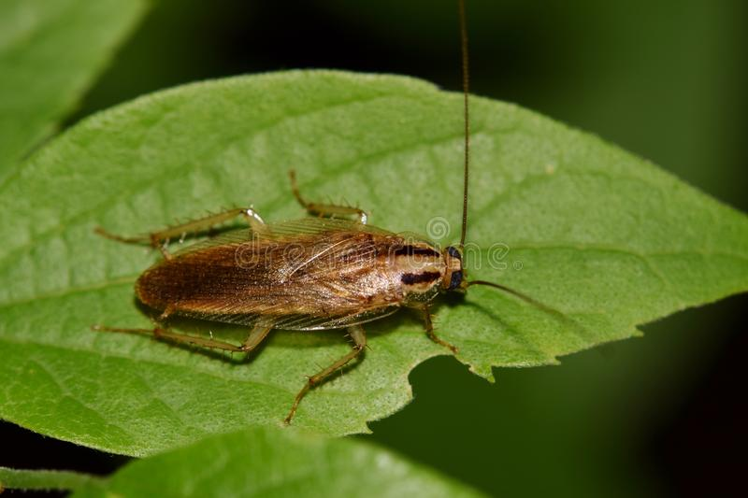

**WORLD PEST CONTROL & LOGISTICS** is one of the upcoming Pest Management Companies in Kolkata and a pioneer and leader in the Pest Management Industry, celebrating over 10 Years as an Organization.

We offer Integrated Pest Management Solutions to customers with our proven expertise in terms of our tailor-made protocols to suit the individual needs and expectations of our clients keeping in focus their ever-changing needs at one end and our years of reputation on the other end. With our nationwide presence, we have a dedicated, highly experienced and committed team of technicians, supervisors and support staff backed up by technical competence, strong ethics and values that keeps us ahead of our competitors.

We have set for ourselves s standard of excellence above the industry standards by identifying and meeting the demands of a rapidly changing market and developing new ways and means by participating with the industry to ensure that the best result is achieved at bare minimum cost.

[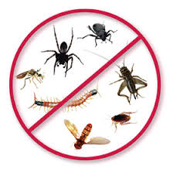](http://www.google.co.in/url?sa=i&rct=j&q=&esrc=s&source=images&cd=&cad=rja&uact=8&docid=OYsDlgyDg2i09M&tbnid=QqJ8N3Sq16yckM:&ved=0CAUQjRw&url=http://www.bunburypestandweed.net.au/pest-control-services-bunbury/&ei=ogDrU6yMDcfs8AXFuoCoAg&bvm=bv.72938740,d.dGc&psig=AFQjCNF4_Itblvug2t_UwjRWUbZkVZdacQ&ust=1407996448280183)



**World Pest Control & Logistics** carries out specialized treatments to satisfy the pest management needs of:

Residential premises, Restaurants, Food processing units, Warehouses, Factories, Ships etc

World Pest Control & Logistics follows self-evolved audit system to satisfy customers which includes:

* Survey & Inspection
* Identification
* Treatment
* Follow up
* Evaluation

This approach either fully or partly is applicable for use in any type of pest management or fumigation work.

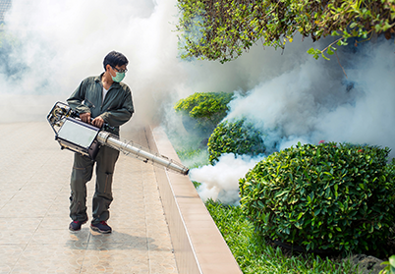

World Pest Control & Logistics specialized service includes:

1. General insect & pest control, Rodent control, Mosquito control, Prophylactic treatments against crawling insect/pest, weed control etc

[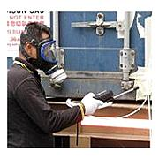](http://www.thegreenbook.com/products/container-fumigation-service/major-s-pest-management-services-pte-ltd/)

[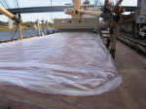](http://www.s-und-a.de/tl_files/Bilder%20Branchen/Schiffahrt.png)

[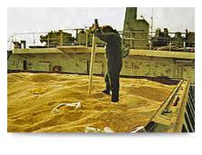](https://www.google.co.in/imgres?imgurl=http://www.expurgaguacu.com.br/imagens/fotos_expurga/foto29.jpg&imgrefurl=http://www.expurgaguacu.com.br/en/tratamento_fitossanitario_quarentenario.html&docid=ccuEnDkYFnnbNM&tbnid=lCP_utF0SYzyYM:&w=278&h=214&ei=NQvrU7fDDYrn8AX7yIHYCg&ved=0CAIQxiAwAA&iact=c)[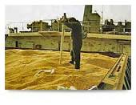](http://www.google.co.in/url?sa=i&rct=j&q=&esrc=s&source=images&cd=&cad=rja&uact=8&ved=0CAQQjRw&url=http://www.expurgaguacu.com.br/en/tratamento_fitossanitario_quarentenario.html&ei=MgvrU6ixN5a78gXS_YDIBA&bvm=bv.72938740,d.dGc&psig=AFQjCNFopK-0rOc4TeZgmgPRJ2TC32V1Gg&ust=1407999154958453)

**2. Termite treatment under Warrantee**

* Both pre & post construction treatment

**3. Microbe & Bacterial Sterilization**

* Hospitals
* Pathological labs
* Machinery
* Offices
* Warehouses

y More

